Use Case Document
Digital Banking – Money Movement – CAFT

Version: DRAFT 1.01
Date Last Published: June 17, 2020
Date Signed: Click here to enter a date.
Use Case Document Author(s):
Neil Cory

Contents
Document Information 3
Revision History 3
Related Document References 3
Use Case CAFT UC001– Originator Profile Maintenance 4
Business Requirements 7
Appendix A - CAFT Originator Information Requirements 7
Appendix B – Originator Input Screen Examples 9
Use Case CAFT-UC002 – CAFT Processing and Settlement 13
Business Requirements 15
Appendix – Processing and Settlement Screen Captures 16
Use Case CAFT-UC003 – Upload External File 20
Business Requirements 22
Appendix - CAFT Screen Captures – File Upload 22
Use Case CAFT-UC004 – Late File Manual Release 23
Business Requirements 25
Appendix - CAFT Screen Captures – Late File Manual Release 26
Related Documents 28
Signature 29

Document Information

Revision History
Include signatures as part of the history
Version | Date | Authors | Revision Notes
1.00 | June 15, 2020 | Neil Cory | Initial draft. Included Originator Profile Management only.
1.01 | June 19, 2020 | Neil Cory | Updated with Processing and Settling Transactions, Upload External File, Late File Maintenance, and attached CPA Standard 5 spec document

Related Document References
[List all relevant documents, such as: business case, existing business and IT Architecture models, roadmaps, document and model templates, standards, glossaries, etc. Include the version number, if appropriate.]
Ref | Document Name | Short Description and URL
1.0

Use Case CAFT UC001– Originator Profile Maintenance

Use Case ID: | UC001- CAFT
Use Case Name: | Originator Profile Maintenance
Created By: | Neil Cory | Last Updated By: | Neil Cory
Date Created: | June 16, 2020 | Date Last Updated: | June 17, 2017
Use Case Description: | An approved customer needs to have an Originator ID created and users created or modified to use the CAFT Service. The information required has been capture by Branch Cash Management and now the customer CAFT users must be set up or modified on Spotlight to enable the request or change.
Actors: | Cash Management Support
Pre-Conditions: | - Infinity and Spotlight are both configured and integrated with a CAFT service provider.  - The requesting customer is approved to make CAFT transactions  - All required customer information for Originators has been captured and provided to Cash Management  - Cash Management is logged into Infinity and ready action branch request in Originator Profile Management module of Infinity  - New Users have been on boarded to Infinity and have a current username and password
Post-Conditions: | - Customer Originator Number(s) have been created  - Customer identified users have been set up with user ID’s  - Customer identified users have been provided temporary passwords to access Infinity CAFT service  - Customer is enabled for direct entry file creation on Infinity  - Customer is enable for upload of a file from a third party application  - The changes to the customer Originator Profile are complete.
Basic Flow: | - User navigated to Manage Originators Module of Infinity  - Add New Originator is selected to reveal the required fields  - Enter requesting branch information from brand provided information  - Enter Username as captured by the branch (current state assigned by CUOS, future SSO)  - Select add as a new user  - Select user access level as identified by branch  - Enter user ID(s) as provided by the branch (note: User ID should be auto populated based on username when username is searched)  - Enter new Originator ID as captured by the branch  - Enter Originator Short Name as captured by the branch (used on reports)  - Enter Originator Long Name as captured by the branch  - Enter Customer Contact Information (pre-populated when existing Originator based on Originator ID)  - Contact Name  - Contact Email  - Contact Phone  - Contact Fax  - Add Alternate Contact Name and email  - Enter Settlement Account Information where funds will be drawn for payment (could add requirement for account where credits go to)  - Account Number  - Route Number  - Transit Number  - Enter Fee Account Information (were transactions fees will be debited from)  - Account Number  - Route Number  - Transit Number  - Set up limits for new originator (note – current state limits are originator level only). These limits are:  - Per transaction  - Per File  - Daily  - Select flag if CWB will hold late files  - Select flag if CWB requires pre-settlement. (This is determined by the branch. Pre-settlements go to a CWB internal account)  - Select File Release Method  - Manual  - Automatic  - Dual Authorization  - Select how transaction information will be entered for CAFT Service  - Direct Entry  - File Upload  - Enter Account Information for returned items  - Account Number  - Route Number  - Transit Number  - Enter Payment Frequency as selected by customer  - Identify CWB CAFT file review and approve staff (is the configuration required – different levels)  - Save profile information  End Basic Flow
Alternate | 2.a Search Originator ID where making a modification to and existing originator  4.a Add another username as captured by branch documentation. (Repeat steps 5, 6, and 7).  4.b Where the username id to be changed or deleted, enter username into this field. (Where username is already exists in the system the user ID, Action type, User Level should auto-populate)  5.a Delete User: Deletes the user from the Originator Profile ID  5.b Change User: Changes the users Level
Exception: | no exceptions
Use Case Priority: | High Priority
Frequency of Use: | Variable.
Business Rules: | - Originator ID’s are 10 digits (numeric only)  - Originator ID format 30-123456-00  - First two digits are 30 (no business logic)  - Middle six digits are customer CIF  - Last two digits are the sequence the users were added  - There is a maximum of 100 users cumulative across all Originator ID’s for a customer  - Customers can be set up with more than one Originator ID.  - User credentials can be used with multiple Originator ID’s  - Limits are determined through Branch Assessment of the customer
Assumptions: | Branch Process for validating onboarding and capturing information is complete  CAFT service provide is agnostic of Infinity  Single Sign on (from Digital Banking) can be supported by CAFT Service Provider
Issues and Considerations:

Business Requirements
Requirement ID | Description
BR-CAFT-1.00 | CWB Must be able to create originators on behalf of customers
BR-CAFT-1.01 | Must be able to modify originators
BR-CAFT-1.02 | CWB Must be able to delete originators
BR-CAFT-1.03 | CWB Must be able to change the user access level
BR-CAFT-1.04 | CWB Must be able to set a daily limit credit and debit permissions for an originator
BR-CAFT-1.05 | CWB Must be able to set maximum value permissions per transaction
BR-CAFT-1.06 | CWB Must be able to set maximum value permissions per file
BR-CAFT-1.07 | CWB Must be able to set maximum value permissions per daily file
BR-CAFT-1.08 | Must be able to set the maximum number of transactions a user can send.
BR-CAFT-1.09 | Record a Settlement Account ID for Originator
BR-CAFT-1.10 | Record a Pre-Settlement Account ID for Originator
BR-CAFT-1.11 | Originators must have the option of setting transactions to manual release transactions
BR-CAFT-1.12 | Originators must have the option of setting transactions to manual release transactions with dual authorization
BR-CAFT-1.13 | Customers can be set up with more than one Originator ID.
BR-CAFT-1.14 | User credentials can be used with multiple Originator ID’s
BR-CAFT-1.15 | Must be able to support user limits and permission settings for Independently for each authorized user (can be a super user on one Originator ID and a Data Entry Only on the Other ID)
BR-CAFT-1.16 | Must be able to set the user permissions for frequency of transactions

Appendix A - CAFT Originator Information Requirements
Field Types | Field name
Branch Information | Branch Name
Branch Information | Branch Route Number
Branch Information | Branch Transit Number
Branch Information | Branch Phone Number
Customer User ID | User Name
Customer User ID | Action (New User, Delete User, Change From, Change To)
Customer User ID | User Level Assign - (S) Super Level, (D) Data Entry, Read Only, Authorize Only
Customer User ID | Add User
Originator/Client Information | Originator ID
Originator/Client Information | Originator Short Name
Originator/Client Information | Originator Long Name
Customer Contact Information | Customer Contact Name
Customer Contact Information | Customer Contact Phone
Customer Contact Information | Customer Contact Email
Customer Contact Information | Customer Contact Fax
Customer Contact Information | Customer Contact
Customer Contact Information | Alternate Contact Name
Customer Contact Information | Alternate Contact Email
Settlement Account | Settlement Account ID
Settlement Account | Settlement Route Number:
Settlement Account | Settlement Transit Number:
Limits | maximum value per transaction
Limits | maximum value per file
Limits | maximum value per daily file
Transaction Exception Flags | Hold Late Files
Transaction Exception Flags | Pre-Settlement Required
CWB Resettlement Account | CWB Account ID
CWB Resettlement Account | CWB Route Number
CWB Resettlement Account | CWB Transit Number
File Release Flag | Manual File Release
File Release Flag | Automatic File Release
File Release Flag | Dual Authorization File Release
Originator Type | Data Entry
Originator Type | File Upload
Originator Type | File Upload Software Type
File Type Flag | Debit Flag
File Type Flag | Credit Flag
Returned Items | Returned Items Account Number
Returned Items | Returned Items Route Number
Returned Items | Returned Items Transit Number
Payment Frequency | Schedule Business Day 1 - Day of Month
Payment Frequency | Schedule Business Day 2 - Day of Month
Payment Frequency | Schedule Business Day 3 - Day of Month
Payment Frequency | Schedule Business Day 4 - Day of Month
Payment Frequency | Schedule Monthly Day
Payment Frequency | Semi Monthly Flag
Payment Frequency | Bi- Weekly Flag
Payment Frequency | Custom Frequency
CWB Cash Management Approvers/Reviewers | Number of Branch Users
CWB Cash Management Approvers/Reviewers | Names
CWB Cash Management Approvers/Reviewers | View Only User ID
CWB Cash Management Approvers/Reviewers | Late File User ID
CWB Cash Management Approvers/Reviewers | Password Reset User ID

Appendix B – Originator Input Screen Examples
B.1 Originator Management on CUPS
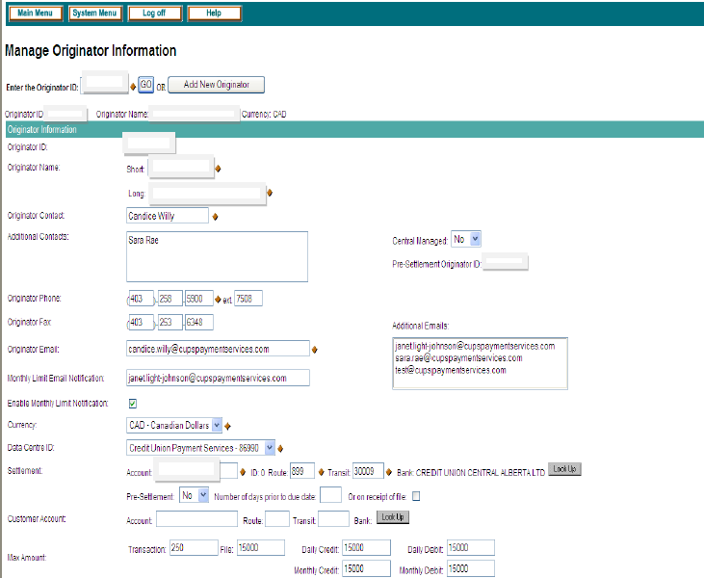

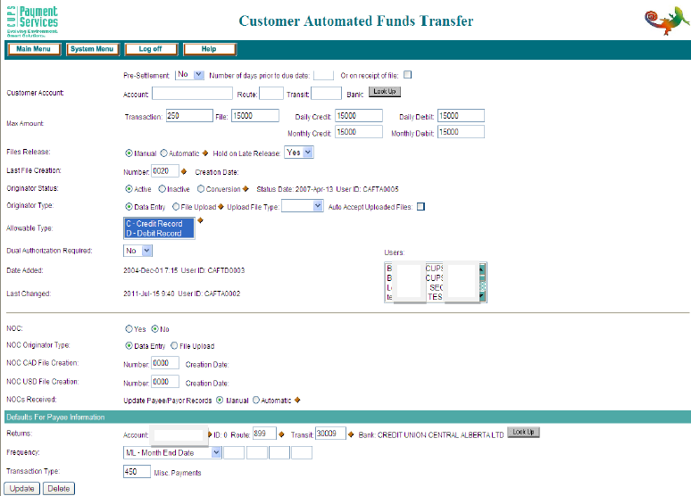

B.2 CWB Profile Creation
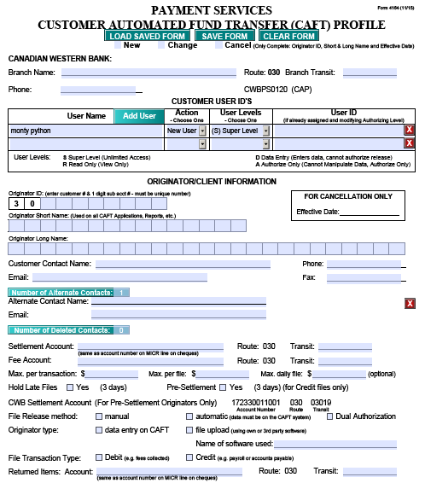

Use Case CAFT-UC002 – CAFT Processing and Settlement

Use Case ID: | CAFT UC002- Processing and Settling
Use Case Name: | Processing and Settlement
Created By: | Neil Cory | Last Updated By: | Neil Cory
Date Created: | June 16, 2020 | Date Last Updated: | June 16, 2020
Use Case Description: | An approved Data Entry CAFT user must initiate a new payment(s) by direct entry into the Infinity CAFT Module. The basic flow details creating a new payee record to make a payment. The alternate flows details creating a payment from existing payees transaction that have been previously saved and updating the required information.
Actors: | Data Entry Originator, Infinity Payor/Payee Management Module, CAFT Service Provider, Payor/Payees
Pre-Conditions: | - Infinity and Spotlight are both configured and integrated with a CAFT service provider.  - Customer has been approved via branch processes.  - On Boarding Documentation has been completed  - Customer is logged into Infinity to the Infinity Module for adding a new payor or payee.
Post-Conditions: | - Payment files are successfully processed by the service provider and the funds are posted to the payor/payees accounts.  - Payment file transactions are not processed by the service provider and return back to the Originators designated return account.
Basic Flow: | - Originator creates a new payment by adding a payee record (record type is credit or debit, will be dependant on the Originator ID)  - Adds Account Information to payee record (account number, institution, transit)  - Add Payee Name  - Add Transaction Due Date  - Adds Cross Reference Number (ex. Invoice number for payment)  - Adds Payment Amount  - Sets Payment Frequency (requirements for frequency : One time, scheduled days of Month (ex: 15th, 30th), Monthly scheduled date, every two weeks)  - Sets Payment Expiry Date  - Return account number (configured at Originator ID set up)  - Save Payee information  - Release Transaction Manually  - Receive Notification of Transaction Details  End Basic Flow
Alternate | 1.a From the add payment menu the user searches for and selects existing payee to start a transaction  1.b From the add payment menu the user searches for and selects multiple payees to make multiple transactions  1.c From the transactions menu the user searches for a previous transaction.  2.a The user edits the payee account information where needed  4.a Edit Transaction Due Date  5.a Edit Cross Reference Number (ex. Invoice number for payment)  6.a Edit Payment Amount  7.a Edit Payment Frequency (requirements for frequency : One time, scheduled days of Month (ex: 15th, 30th), Monthly scheduled date, every two weeks)  8.a Edit Payment Expiry Date  11.a Originator transactions are set to release automatically  11.b The Originator permissions require Dual Authorization. The Authorizing user gets an alert that a file requires authorization.  11.c The Authorizing User reviews the file details and approves or declines the file.  11.d The Originator requests a recall of the transaction file.  12.a Payment file is rejected for errors. The CAFT Originator receives an alert with the details of the error makes and makes any changes and re-releases the file.  12. b Debit or credit transactions are returned and posted back to Originators return account. The CAFT Originator receives an alert.  12.c Recalled transactions are returned back to the originators return account.  End Alternate Flow
Exception: | Payment Files uploaded from external systems
Use Case Priority: | High Priority
Frequency of Use: | Variable.
Business Rules | - Transaction limits and user permissions are determined at onboarding  - The funding  - The requirements for Originator presettlement is determined at onboarding  - Funds need to be in the settlement account at presettlement or at settlement  - Transaction recalls must be made x days by Service Provider
Assumptions: | CAFT service provide is agnostic.
Issues and Considerations:

Business Requirements
Requirement ID | Description
BR-CAFT-1.17 | Ability to create a new payment template from direct entry transactions
BR-CAFT-1.18 | Ability to create a new collection template from direct entry transactions
BR-CAFT-1.19 | Ability to create a new template from saved sets of EFT collection templates
BR-CAFT-1.20 | Ability to create a new template from saved sets of EFT payment templates
BR-CAFT-1.21 | Ability to search previous payment files
BR-CAFT-1.22 | Ability to search previous collection files
BR-CAFT-1.23 | Ability to Modify existing templates to initiate a new transaction
BR-CAFT-1.24 | Must be able to save a payment file as a template for re-use in the future
BR-CAFT-1.25 | Must be able to save collection transactions as a template for future use
BR-CAFT-1.26 | The ability to display the list of all ACH payment transactions that are made using ACH.
BR-CAFT-1.27 | User should be able to view and take action on the transactions awaiting approval.
BR-CAFT-1.28 | Ability to approve ACH transactions.
BR-CAFT-1.29 | Ability to create a new template from saved sets of EFT payment and collection templates.
BR-CAFT-1.30 | The ability to display the list of all EFT payment and EFT collection transactions that are made using EFT.
BR-CAFT-1.31 | Ability to approve EFT transactions. User should be able to view and take action on the transactions awaiting approval. User should be able to approve or decline transaction
BR-CAFT-1.32 | User should be able to decline transaction (Unclear)
BR-CAFT-1.33 | Ability to view the list of pending file uploads that need the approval to complete the process.
BR-CAFT-1.34 | User should be able to approve or reject files as required
BR-CAFT-1.35 | Must be able to enter data directly into system (Infinity) which will create transaction files in CPA Standard 005 format
BR-CAFT-1.36 | Must be able to make mass changes on an existing temple (example the recurring date changes on a template)
BR-CAFT-1.37 | Must be directly upload transaction files in CPA Standard 005 file created from another system into CAFT system
BR-CAFT-1.38 | Must be able to review the contents of an uploaded CPA Standard 005 file
BR-CAFT-1.39 | Users must be able to preview the total value of credits in an uploaded file to confirms correctness
BR-CAFT-1.40 | Users must be able to preview the total value of debits in an uploaded file to confirm correctness
BR-CAFT-1.41 | To confirm correctness must be able to review the total number of transaction items in a files
BR-CAFT-1.42 | Must be able to confirm and accept or decline an uploaded CPA Standard 005 files

Appendix – Processing and Settlement Screen Captures
- Direct Entry Of New Payor/Payee
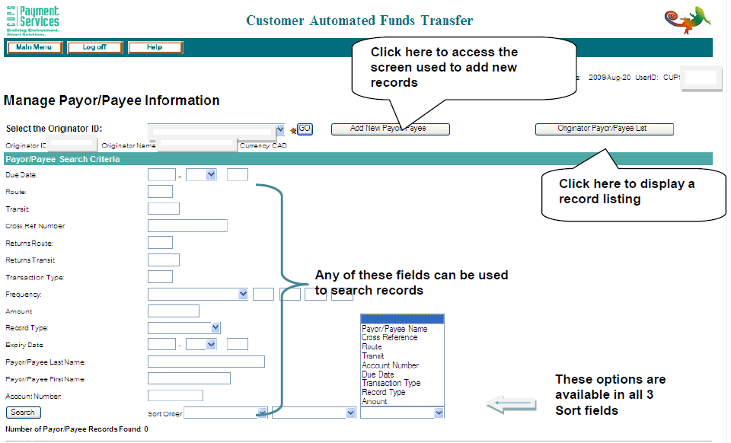

- Search Existing Payor/Payee
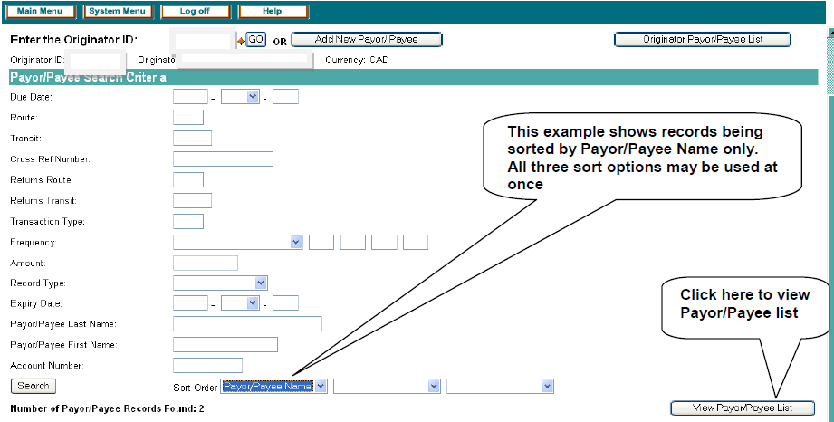
- Returned Record Search – Update for New Transaction
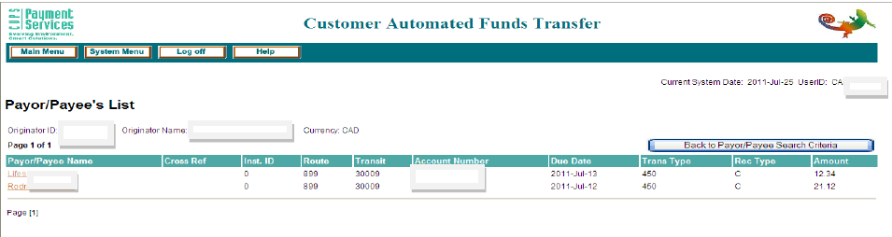

- Example Record
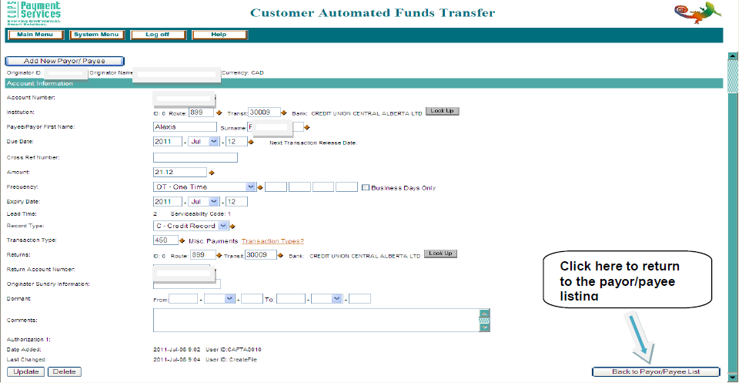

- Payor/Payee - Multiple Changes (Best Used fro Payroll)
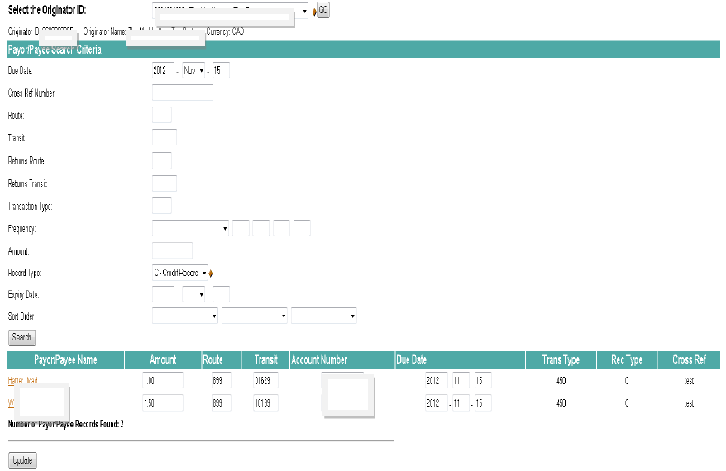

Use Case CAFT-UC003 – Upload External File

Use Case ID: | CAFT UC 003 – Upload External File
Use Case Name: | Initiate Transaction File via external file upload
Created By: | Neil Cory | Last Updated By: | Neil Cory
Date Created: | June 17, 2020 | Date Last Updated: | June 17, 2020
Use Case Description: | An approved CWB CAFT user initiates a payment by uploading a payment file from a third party application (an accounting package).
Actors: | CAFT Originator, Infinity CAFT Module, Third Party Software
Pre-Conditions: | - Customer is logged into Infinity  - The Customer has created a payment file in CPA Standard 5 format
Post-Conditions: | - File is successfully uploaded to CAFT Service Provider
Basic Flow: | - Through file upload module, customer browse to and selects file for upload  - File is uploaded for and record content is displayed (number of transaction items and values)  - User reviews the upload details of the file and Accepts the file upload  - User gets on screen conformation that files had been uploaded.  End Basic Flow
Alternate | 3.a The user reviews the file upload details and declines upload  4.b The User gets notification that Dual Authorization of file upload is required  4.c Authorizing User gets an alert that a file has been uploaded and requires secondary authorization  4.d. Authorizing User logs into Infinity  4.e. Authorized user select file in list of files requiring authorization  4.f Authorizing user reviews the file details  4.g The file is Authorized or declined.  4.h The Originating user gets notification that the file has been approved and uploaded.  End Alternate Flow
Exception:
Use Case Priority: | High Priority
Frequency of Use: | Variable.
Business Rules | - User needs to have the correct permissions set in the Originator Profile  - Dual Authorization is set in the Originator Profile  - External File is a CPA STD 005 file
Assumptions: | CAFT service provide is agnostic.
Issues and Considerations:

Business Requirements

Requirement ID | Description
BR-CAFT-1.43 | Must be directly upload transaction files in CPA Standard 005 file created from another system into CAFT system
BR-CAFT-1.44 | Users must be able to preview the upload file to preview the total value of credits in an uploaded file to confirms correctness
BR-CAFT-1.45 | Users must be able to preview the total value of debits in an uploaded file to confirm correctness
BR-CAFT-1.46 | Users must be able to preview the upload file to confirm correctness must be able to review that total number of transaction items in a files
BR-CAFT-1.47 | Must be able to confirm and accept an uploaded CPA Standard 005 files
BR-CAFT-1.48 | Must be able to confirm and decline an uploaded CPA Standard 005 files

Appendix - CAFT Screen Captures – File Upload
- Upload Window
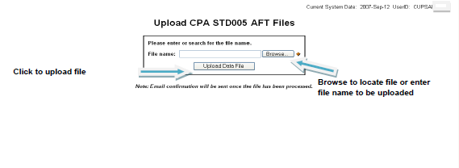

- Upload Result Window
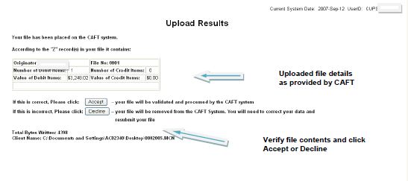

Use Case CAFT-UC004 – Late File Manual Release

Use Case ID: | UC004 – Late File Manual Release
Use Case Name: | CAFT Late File Manual Release
Created By: | Neil Cory | Last Updated By: | Neil Cory
Date Created: | June 17, 2020 | Date Last Updated: | June 17, 2020
Use Case Description: | An Originator has submitted a file within after predetermined date before the file due date. The file by business rule us late. A CWB Authorizer reviews the file(s) to authorize.
Actors: | CWB CAFT Authorizing User(s), Originators, Infinity CAFT Module, Spotlight 360
Pre-Conditions: | Customer has released a payment file after the required deadline to submit (business rule).  Receives an alert of a late file  Authorizing User is logged into CAFT Authorize Module of Infinity
Post-Conditions: | - The late file is authorized and manually released to the CAFT Service Provider.  - The late file is rejected and not released.
Basic Flow: | - The Authorizing User reviews the late file by each Originator ID.  - Authorizing User selects late payment file for the Originator ID  - Authorizing will review the contents of each file (the total number of credits and total number of debits)  - Authorizing user authorizes late file (there maybe more than one late file, return to step 2)  - Authorizing User reviews list of authorized late files  - Authorizing User confirms the release of CAFT Transactions for the originator.  - Originator receives and alert that the late file has been released  - Branch receives notification that a late file has been released by the customer. Reviews customer history (KYC) to determine if hold on customer account is needed.  End Basic Flow
Alternate | 4.a Authorizing user rejects the late file  4.b Authorizing user un-authorizes a previously authorized late file  6.a. The Originator ID is configured for Dual Authorization for manual release. The Authorizer receives a system prompt that secondary authorization is required.  6.b. The Secondary Authorizing user receives and alert that a late CAFT file requires authorization.  6.c. The CWB secondary authorizer reviews a list of manually released files from the first authorizer and confirms or rejects the authorized files.  6.d. Originators that are configured for “Hold Late Files” require branch approval for release of late files will receive and on screen message that branch must approve. (Note: See Business Rules)  7.a The Originator receives and email that the late file has been rejected
Exception:
Use Case Priority: | High Priority
Frequency of Use: | Variable.
Business Rules: | Late Files are considered those that are delivered less that (x) days* prior to the due date.  *note: Until January 2020 the business rule was 3 days. Current state one day with any late files being released automatically.
Functional Requirement:
Assumptions: | CAFT service provide is agnostic.
Issues and Considerations:

Business Requirements
Requirement ID | Description
BR-CAFT-1.49 | CWB must be alerted when an Originator submits a CAFT file within X days of the file due date
BR-CAFT-1.50 | CWB must authorize, unauthorized (when authorized by mistake), or reject a late file to be processed by the CAFT service provider
BR-CAFT-1.51 | CWB authorizer must be able to review the contents of each Originator late file (the total number of debits and credits in each file)
BR-CAFT-1.52 | CWB must be able to confirm the authorized files before they are released
BR-CAFT-1.53 | CWB must be able to configure Originators for dual authorization of late file release
BR-CAFT-1.54 | A secondary late file authorizer must be alerted when an initial authorization of a late file is made (secondary authorizers should be at branch)
BR-CAFT-1.55 | The CWB secondary late file authorizer must be able preview the total value of credits and debits made by the primary authorizer
BR-CAFT-1.56 | The CWB secondary late file authorizer must confirm or reject the initial authorization
BR-CAFT-1.57 | Originators must receive an email with the approval confirmation of a late file
BR-CAFT-1.58 | Originators must receive an email with the rejection confirmation of a late file (note: the reason for rejection is not included in the email, the user must review log files to determine - opportunity for improvement)

Appendix - CAFT Screen Captures – Late File Manual Release

- Authorizer Review Screen
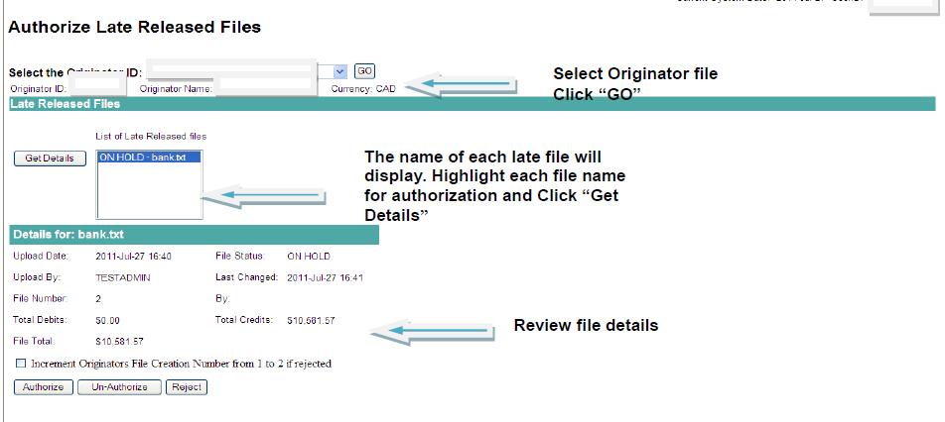

- Late Transaction Confirmation

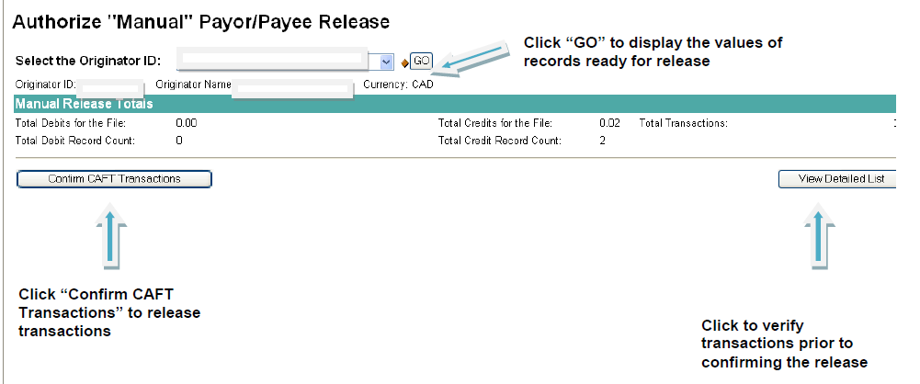

- Dual Authorization
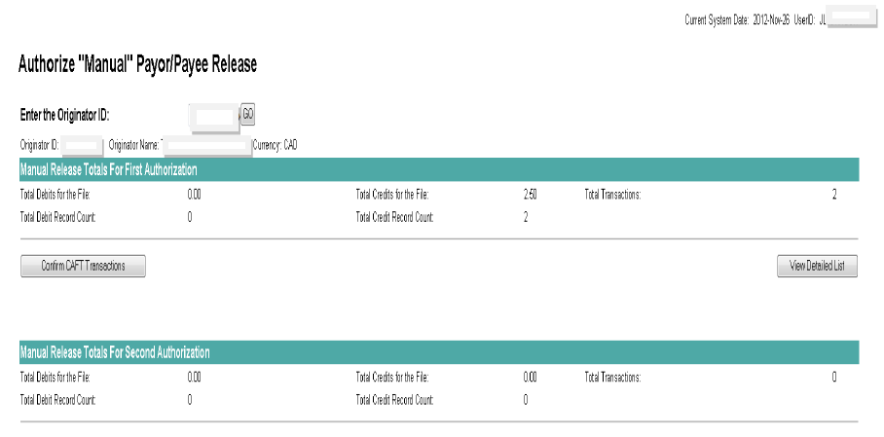

Related Documents
- CPA Standard 005

Signature
This section contains the signatures of the primary key stakeholders indicating acknowledgement and acceptance that the information collected in this document represents the interests of all business area stakeholders listed in the Stakeholder section.
Role | Name & Title | Date | Digitally Approved
☐
Add to history that doc was digitally approved
☒
Add to history that doc was digitally approved
☐
Add to history that doc was digitally approved

